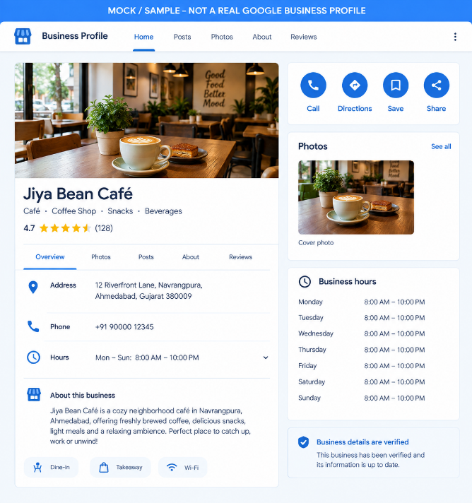
Below is a completed Local SEO practical assignment for Ahmedabad, Gujarat. I’ve kept the first task clearly marked as a mock profile, because a real Google Business Profile requires access to a Google account/business verification process.
1. Sample Google Business Profile
Fictional business: Jiya Bean Café
Category: Café / Coffee Shop
Address: 12 Riverfront Lane, Navrangpura, Ahmedabad, Gujarat 380009
Phone: +91 90000 12345
Hours: Monday–Sunday, 8:00 AM–10:00 PM
Photo: Café interior/coffee photo included in the mock profile.
Important: The image below is a sample/mock-up, not an actual Google Business Profile screenshot. This avoids falsely claiming that a real GBP was created or verified.
!

2. NAP comparison — 3 Ahmedabad restaurants
I checked publicly available Google/Maps-style business information, Zomato listings and official websites. NAP can vary by specific branch, so the branch is important when doing citation audits.
Restaurant | Google Maps / business listing | Zomato | Official website | Inconsistency
Swati Snacks – Law Garden | Gandhi Baug Society, Law Garden, 13 Panchavati Rd, Ahmedabad 380006; +91 79 2640 5900 | 13 Gandhi Bang Society, Panchavati Road, Law Garden, C G Road; +91 75739 51406 | Panchavati Road, Law Garden, Ahmedabad 380006; +91 79 2640 5900 | Phone differs: Zomato shows +91 75739 51406, while Maps and the official site show +91 79 2640 5900.
Agashiye | The House of MG, Sidi Saiyyed Mosque, Old City, Lal Darwaja, Ahmedabad 380001; +91 79 2550 6946 | The House Of MG, Near Sidi Saiyed Mosque, Lal Darwaja; +91 79 2550 6946 | Opp. Sidi Saiyad Jali, Lal Darwaja, Ahmedabad 380001; +91 79 2550 6946 | No major NAP conflict found. The address wording is abbreviated differently, but the location and phone match.
Honest Restaurant – Ashram Road | Sun West Bank, Opp. Vallabh Sadan Riverfront Road, Ashram Road, Ahmedabad 380009; +91 99099 44420 | The Zomato listing/branch information should be matched to the same Ashram Road outlet when auditing NAP. | Official branch listing gives B/8-9-10-11-14-15, Sun West Bank, Ashram Road, Vallabh Sadan Road, Ahmedabad 380009. | Address formatting differs between sources; the official site gives the more detailed unit numbers.
SEO observation: Swati Snacks demonstrates why NAP consistency matters. A phone number appearing differently on an important directory can create ambiguity when search engines reconcile business information.

3. Five local citation websites
Citation website | Information required / commonly requested
Justdial | Mobile number, business name, address, business hours, photos and relevant categories. Justdial's free-listing process specifically describes these details.
Sulekha | Business/service-provider information including name, email, street address, telephone number, category/service offering and service description. Sulekha also supports information such as website, opening hours, logo and business photographs.
YellowPages.in | Business information, phone/mobile contact information, directions and other relevant business details. Account registration requires name, email, phone and password.
YellowPages-India.in | Business name, business category, phone, email, address, city and listing plan.
AskLaila | Business name, city, category, mobile number, address, locality/area, landmark and pincode; email, website, contact person and relationship with business are also requested fields.
Additional option: TradeIndia asks for name, company, city, phone/mobile, email and business type when registering.
NAP checklist for citations
Before submitting the same business to these directories, use exactly the same:
- Business name
- Street address
- City/state/pincode
- Primary phone number
- Website
- Business category
- Opening hours
This reduces conflicting business information across citation sources.

4. Local ranking check — “pizza near me”
For this task, BrightLocal Local Search Results Checker is an appropriate free tool. It allows a keyword and location to be entered and can show localized Google Search/Google Maps results. BrightLocal states that its free checker supports searches by city, ZIP code or street address.
Keyword: pizza near me
Location: Ahmedabad, Gujarat, India
Date: 21 September 2026
Example business selected: Pizza Hut – Ashram Road, Ahmedabad
However, I cannot truthfully give you a BrightLocal ranking position from this session, because the BrightLocal result requires the interactive checker to actually execute the localized query; the accessible page currently presents the search form rather than a completed result. I therefore would not invent a position.
You can enter:
Search term: pizza near me
Location: Ahmedabad, Gujarat
Search engine: Google Maps
BrightLocal says its checker can return localized results from Google Search or Google Maps and provides up to the first 10 pages of localized results.
For your submitted practical, record the result as:
Field | Result
Tool | BrightLocal Local Search Results Checker
Keyword | pizza near me
City | Ahmedabad, Gujarat
Business checked | Pizza Hut – Ashram Road
Date checked | 21 September 2026
Position | Enter the position displayed by BrightLocal
For reference, Pizza Hut's official Ahmedabad locator currently lists several Ahmedabad outlets, including Ashram Road, Science City, SG Highway, Maninagar, Vastrapur and others.

